A FRAMEWOK OF NON FUNGIBELE TOKEN MARKETPLACE USING BLOCKCHAIN

*Kalai selvi, assistant professor, department of compuer science and engineering,anjalai ammal mahalingam enhineering college, thiruvarur, india* [*kaliaselvi@gmail.com*](mailto:kaliaselvi@gmail.com)

*Kalai selvi, assistant professor, department of compuer science and engineering,anjalai ammal mahalingam enhineering college, thiruvarur, india* [*kaliaselvi@gmail.com*](mailto:kaliaselvi@gmail.com)

*Kalai selvi, assistant professor, department of compuer science and engineering,anjalai ammal mahalingam enhineering college, thiruvarur, india* [*kaliaselvi@gmail.com*](mailto:kaliaselvi@gmail.com)

***Abstract -In this Non fungible token marketplace as the name implies,a decentralized platform where can create,buy,sell and store a non fungible token marketplace token.an non fungible token marketplace minting and trading as a global scale,while blockchain as its underlying technology ensures transferring and immutable recovering of assets tokenization and trading process.The marketplace also cares of NFT storage,NFT are units of data that represents a unique digital asset stores and verified on the blockchain .in this blockchain .in this paper need to import both the NFT contract and fungible token contract for sale ,price changed.token.purchased and sales withdrawn .in this paper a building a simple react app that contracts with flew smart contracts to validate and fetch NFTS owned by users***

***Keywords-Smart Contacts, Non fungible Tokens, Digital Assets.***

INTRODUCTION

NFT marketplace, as the name implies, is a decentralized platform where users can create, buy, sell, and store non-fungible tokens. An NFT marketplace facilities NFT minting and trading at a global scale, while blockchain as its underlying technology ensures transparency and immutable recording of the digital asset tokenization and trading process. The marketplace also takes care of NFT storage.NFT marketplaces are gaining traction in industries such as gaming, art, social networking, and music, nearly capturing every market that deals with digital assets. With the influx of Metaverse projects, NFT marketplaces have grown into prominence and relevance even further.With time, the features of NFT marketplaces are upgrading, and limitations like lack of NFT interoperability are getting addressed. Cross-chain bridging, niche-specific NFTs, NFT swapping, and compatibility with multiple metaverse projects are some of the advanced features of contemporary NFT marketplaces.

One important factor to consider before developing your NFT Marketplace project is the niche. However, above and beyond niche, there are numerous layers to consider like the blockchain protocol, the NFT storge, architecture designing, and others. Here, this insight covers all about NFT marketplace development. Before diving deep into how an NFT marketplace is created, it is essential to understand how the NFT marketplace works from the client side. Usually, all NFT platforms share a similar workflow. Firstly, a user has to sign up on the platform and install a digital wallet to store NFTs.Users can then create their assets by uploading items to exhibit their work. The user can also select which payment tokens they would like to accept for their art and set a fee if the platform suggests it. The next step in the workflow is to list items for sale. The user can choose a bid for a fixed price or an auction. A transaction is created when listing an item for sale to launch a personal trading smart contract for the user wallet.The platform may need a collection moderation and NFTs will appear on the list after approval.

RELATED WORK

NFT marketplace, as the name implies, is a decentralized platform where users can create, buy, sell, and store non-fungible tokens.An NFT marketplace facilities NFT minting and trading at a global scale, while blockchain as its underlying technology ensures transparency and immutable recording of the digital asset tokenization and trading process. The marketplace also takes care of NFT storage. Nonfungible tokens are units of data that represent a unique digital asset stored and verified on the blockchain.We present an examination of a few famous and as of now working decentralized applications which depend on theERC721 standard. We then decide a rundown of regularly experienced elements and augmentations in this application space. These act as the reason for the brilliant agreement suite are assemble. We then, at that point, characterize a SL that utilizes the suite to get different deployable designs of the agreements.To recognize well known and as of now workingERC721 savvy contracts, we have chosen the top mostdynamic brilliant agreements in light of the new number of exchanges. Etherscan permits us to investigate Ethereum blockchain in view of exchange action and channel on ERC721 agreeablecontracts We chose the best ten savvy contracts whenarranging by the quantity of exchanges acted in the last seven days and furthermore guaranteeing that there is some degree of actionon the brilliant agreement in the last twentyfour hours. We gathered the accompanying rundown (in diminishing request of action): CryptoKitties, DozerDoll, GodsUnchained, LucidSight-MLB-NFT, MARBLE-NFT, MyCryptoHeroes:Extension CryptoFlowers, Ethereum Name Administration,MyCryptoHeroes:Hero, Spheroid SPACE. Eight of the ten applications are blockchain-basedgames. The leftover two are expanded reality diversion and publicizing, and a decentralized name administration.

METHODOLOGY

Non-fungible tokens are an exceptional application space for brilliant agreements. Ethereum is the first blockchain-based decentralized processing stage that has normalized this kind of token into a clear cut interface in particular ERC721. We propose a structure that gives designers with a shrewd agreement suite that offers total executions of the ERC721 standard and normal expansions also, includes every now and again experienced in ERC721-based applications. We present a detail language that empowers customization and arrangement of the shrewd agreement suite by counting and barring the upheld elements and expansions. We assess the savvy contract suite for its extensibility furthermore, reusability and contrast the measurements and four reference executions handling a comparable issue. Furthermore, we assess and break down the work and productivity of the detail language in contrast with manual design of the brilliant agreement suite. Our commitment lies in looking at quality measurements for code extensibility and reusability and deciding the more sagacious measurements for evaluating these qualcredits with regards to Robustness smart contracts. Also, from the lines of code metric, We reason that our determination language offers a basic and effective option in contrast to manual brilliant agreement suite customization.

1. *Storefront*

NFT marketplace should have a storefront that offers users all the information required for an item: bids, owners, preview or price history.

1. *Filters*

Using filters, it becomes easier to navigate a site, specifically if you plan to build a marketplace place for a lot of collectibles. By adding the filters feature, users can select items by payment method, listing status, category and collection.

1. *Searchingitems*

An NFT marketplace platform should support tagging and category management to allow users to search collectibles. Use a search bar on the site and add categories.

1. *Create listings*

A user should be able to create and submit collectibles. Using this feature, a user should upload files and fill in the token information such as name, tags, description.

1. *Buy Bid*

The NFT marketplace platform should have a feature that allows users to buy and bid for NFTs listed on the platform. The bidding feature should include a bid expiration date and allow users to view details about the bids’ current status.

1. *Wallet*

The NFT Marketplace Platform should have a wallet that allows users to store, send and receive non-fungible tokens. The easiest way to integrate this feature is to provide users with a connected wallet that they already use. For example, you can integrate the most popular wallets like Coinbase, Formatic or MyEtherWallet.

Below figure shows the system architecture of the proposed system

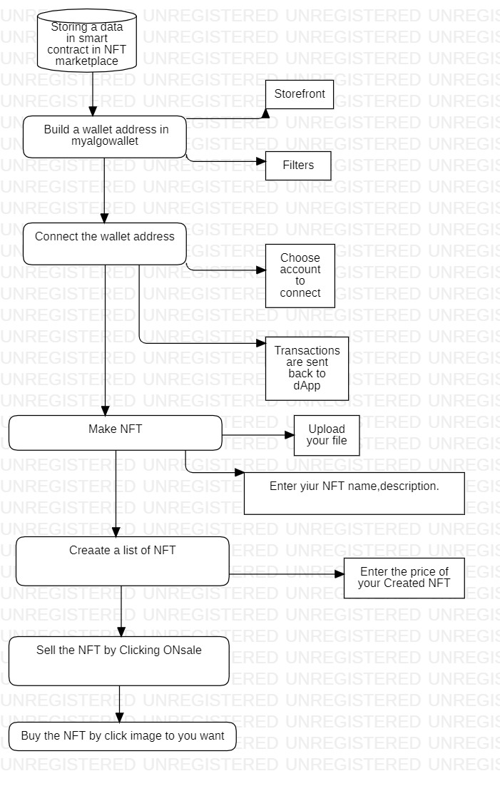

*Smart Contracts*

Smart contracts are simply programs stored on a blockchain that run when predetermined conditions are met. They typically are used to automate the execution of an agreement so that all participants can be immediately certain of the outcome, without any intermediary's involvement or time loss. A smart contract is an agreement between two people in the form of computer code. They run on the blockchain, so they are stored on a public database and cannot be changed. The transactions that happen in a smart contract are processed by the blockchain, which means they can be sent automatically without a third party.

*BENEFITS OF CONRACT*

1. Autonomy and savings. Smart contracts do not need brokers or other intermediaries to confirm the agreement; thus, they eliminate the risk of manipulation by third parties.
2. Backup
3. Safety
4. Speed
5. Accuracy.

Examples of smart contract applications include financial purposes like trading, investing, lending, and borrowing. They can be used for applications in gaming, healthcare, and real estate; and they can even be used to configure entire corporate structures.

*Technology Stack Required for Building an NFT marketplace platform*

1. *Ethereum*

Ethereum is one of the most popular platforms when it comes to NFT marketplace or non-fungible token development. Since transaction history and token metadata is publicly verifiable on Ethereum, it is easier to prove ownership history.As all Ethereum products share the common backend, NFTs become portable across products. Also, Ethereum never goes down; therefore, tokens will always be available for sale.

1. *Flow*

Flow is a rapid and decentralized blockchain designed for a new generation of digital assets, apps and games. The platform is being widely used to create both the NFT marketplace and NFTs using the Cadence programming language.

1. *Tezos*

Tezos is an open-source blockchain platform for applications and assets backed by a community of builders, researchers and validators. Using a pre-compiled FA2 NFT contract written is smart contract language, Tezos supports the development of NFT marketplaces and NFTs.

*Storage Platforms*

1. *IPFS*

IPFS is a peer-to-peer hypermedia protocol designed to store media content in a decentralized way. As the media file related to NFTs cannot be stored directly on the blockchain, IPFS can store all that data.

1. *Filecoin*

Filecoin is a decentralized storage network designed specifically to store the most critical information, such as media files. The storage platform includes everything that a developer will require to get started with decentralized storage for NFTs. Knowing its benefits, Truffle Suite has also launched NFT Development Template with Filecoin Box.

1. *Pinata*

Pinata is also one of the popular platforms to upload and manage files on IPFS. It provides secure and verifiable files for NFTs

*NFT Standards -* ERC-721, ERC-1155, FA2

*Developing and Trading NFT*

Need to import both the NFT contract and the fungible token contract. We have defined four events inside the contract definition

ForSale: NFTs for sale PriceChanged: Change in the price for NFTs TokenPurchased: When NFTs are purchasedSaleWithdrawn: When NFTs are removed from the marketplace

We have added a resource interface called SalePublic below event emitters. The interface should be public to everyone, not only the contract owner.

We need to add a SaleCollection resource below the SalePublic interface. We have defined a few variables within this resource. For example, mapping of tokens for sale, mapping prices for each token for sale and a protected variable that is only accessible by the contract owner called ownerVault.

IMPLEMENTATION AND RESULTS

CONCLUSION

Non fungible tokens are unique pieces of data that are stored on a blockchain .Digital Art, Ticktes are a few examples of the digital assets that are being converted as NFTsOverall NFTs are a new tool that satisfies some of the needs of creator,users, and collectors of a large class of digital and non digital objects. NFTs have been used to exchange digital tokens that link to a digital file asset. Ownership of an NFT is often associated with a license to use such a linked digital asset, but generally does not confer copyright to the buyer. Some agreements only grant a license for personal, non-commercial use, while other licenses also allow commercial use of the underlying digital asset.Finally created NFT gives to sale with fixed price (algos),then also buy this Digital NFT for giving fixed price.

REFERENCES

[1] Dean, Sam (March 11, 2021). "$69 million for digital art? The NFT craze, explained". Los Angeles Times. Retrieved March 12, 2021.

[2] Jump up to:a b Kastrenakes, Jacob (March 11, 2021). "Beeple sold an NFT for $69 million". The Verge. Archived from the original on March 21, 2021. Retrieved March 21, 2021.

[3] Mendis, Dinusha (August 24, 2021). "When you buy an NFT, you don't completely own it – here's why". The Conversation. Retrieved November 23, 2021.

[4] Jump up to:a b c Gault, Matthew (November 3, 2021). "What the Hell Is 'Right-Clicker Mentality'?". Vice. Retrieved November 3, 2021.

[5] WTF Is an NFT, Anyway? And Should I Care?". Wired. ISSN 1059-1028. Retrieved March 13, 2021.

[6] Jump up to:a b Boscovic, Dragan. "How nonfungible tokens work and where they get their value – a cryptocurrency expert explains NFTs". The Conversation. Retrieved April 8, 2021.

[7] Kastrenakes, Jacob (March 25, 2021). "Your Million-Dollar NFT Can Break Tomorrow If You're Not Careful". The Verge. Retrieved March 31, 2021.

[8] Gallagher, Jacob (March 15, 2021). "NFTs Are the Biggest Internet Craze. Do They Work for Sneakers?". The Wall Street Journal. ISSN 0099-9660. Retrieved June 26, 2021